​
​
UNITED STATES
SECURITIES AND EXCHANGE COMMISSION
Washington, D.C. 20549
Form 8-K
CURRENT REPORT
Pursuant to Section 13 or 15(d) of the Securities Exchange Act of 1934
Date of Report (Date of earliest event reported): March 18, 2024
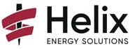
HELIX ENERGY SOLUTIONS GROUP, INC.
(Exact name of registrant as specified in its charter)
​

Minnesota | 001-32936 | 95-3409686
(State or other jurisdiction  of incorporation) | (Commission  File Number) | (IRS. Employer Identification No.)
3505 West Sam Houston Parkway North | ​ | ​
Suite 400 | ​ | ​
Houston, Texas | ​ | 77043
(Address of principal executive offices) | ​ | (Zip Code)
​
Registrant’s telephone number, including area code: 281-618-0400
NOT APPLICABLE
(Former name or former address, if changed since last report)
Check the appropriate box below if the Form 8-K filing is intended to simultaneously satisfy the filing obligation of the registrant under any of the following provisions:
☐ Written communications pursuant to Rule 425 under the Securities Act (17 CFR 230.425)
☐ Soliciting material pursuant to Rule 14a-12 under the Exchange Act (17 CFR 240.14a-12)
☐ Pre-commencement communications pursuant to Rule 14d-2(b) under the Exchange Act (17 CFR 240.14d-2(b))
☐ Pre-commencement communications pursuant to Rule 13e-4(c) under the Exchange Act (17 CFR 240.13e-4(c))
Securities registered pursuant to Section 12(b) of the Act:
​

​ | ​ | ​ | ​ | ​
Title of each class |  | Trading Symbol(s) |  | Name of each exchange on which registered
Common Stock, no par value | ​ | HLX | ​ | New York Stock Exchange
​
Indicate by check mark whether the registrant is an emerging growth company as defined in Rule 405 of the Securities Act of 1933 (§230.405 of this chapter) or Rule 12b-2 of the Securities Exchange Act of 1934 (§240.12b-2 of this chapter).
Emerging growth company ☐
If an emerging growth company, indicate by check mark if the registrant has elected not to use the extended transition period for complying with any new or revised financial accounting standards provided pursuant to Section 13(a) of the Exchange Act. ☐
​
​
​
Item 7.01. Regulation FD Disclosure.
Helix Energy Solutions Group, Inc. (the “Company”) is furnishing this report to disclose an updated Company presentation to be used, or the basis of which will be used, in communications with investors as well as at investor conferences. The presentation materials are attached hereto as Exhibit 99.1 and incorporated by reference herein. The presentation materials are also available on the “For the Investor” page of the Company’s website, www.helixesg.com.
​
​
Item 9.01 Financial Statements and Exhibits.
(d) Exhibits.
​
​ | ​ | ​
Exhibit  Number |  | Description
99.1 | ​ | Materials to be used in communications and at conferences.
104 | ​ | Cover Page Interactive Data File (embedded within the Inline XBRL document).
​
​
SIGNATURES
Pursuant to the requirements of the Securities Exchange Act of 1934, the Registrant has duly caused this report to be signed on its behalf by the undersigned hereunto duly authorized.
​
Date: March 18, 2024 |  | ​
​ | ​ | HELIX ENERGY SOLUTIONS GROUP, INC.
​ | ​ | ​
 | ​ | By: | /s/ Erik Staffeldt
​ | ​ | ​ | Erik Staffeldt
​ | ​ | ​ | Executive Vice President and  Chief Financial Officer
​
​
​

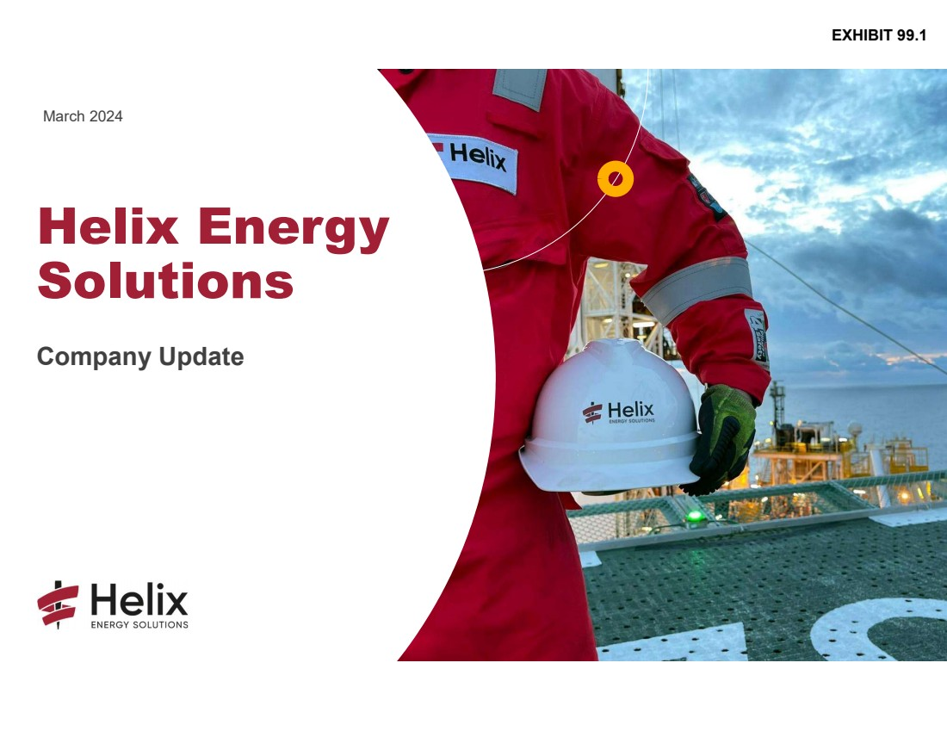 | Helix Energy Solutions Company Update March 2024 EXHIBIT 99.1
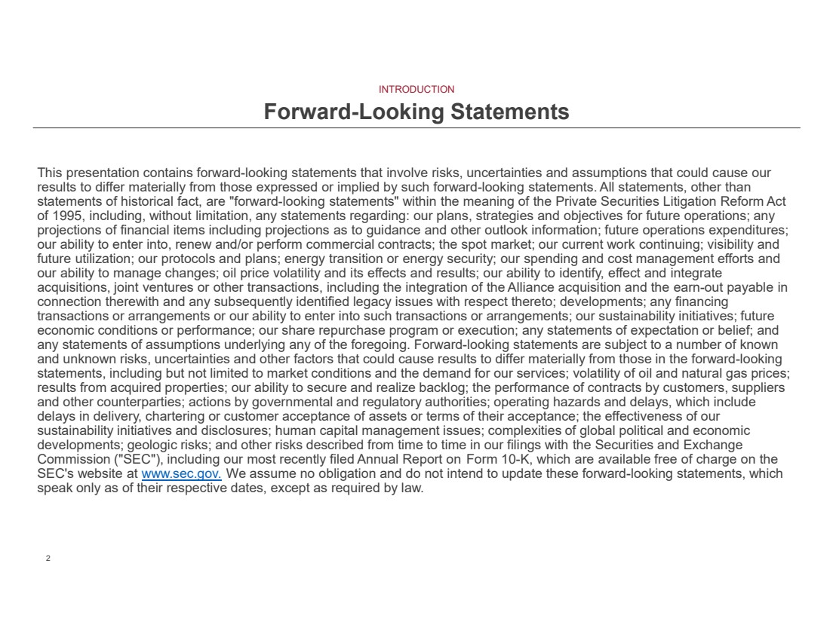 | 2 2 This presentation contains forward-looking statements that involve risks, uncertainties and assumptions that could cause our results to differ materially from those expressed or implied by such forward-looking statements. All statements, other than statements of historical fact, are "forward-looking statements" within the meaning of the Private Securities Litigation Reform Act of 1995, including, without limitation, any statements regarding: our plans, strategies and objectives for future operations; any projections of financial items including projections as to guidance and other outlook information; future operations expenditures; our ability to enter into, renew and/or perform commercial contracts; the spot market; our current work continuing; visibility and future utilization; our protocols and plans; energy transition or energy security; our spending and cost management efforts and our ability to manage changes; oil price volatility and its effects and results; our ability to identify, effect and integrate acquisitions, joint ventures or other transactions, including the integration of the Alliance acquisition and the earn-out payable in connection therewith and any subsequently identified legacy issues with respect thereto; developments; any financing transactions or arrangements or our ability to enter into such transactions or arrangements; our sustainability initiatives; future economic conditions or performance; our share repurchase program or execution; any statements of expectation or belief; and any statements of assumptions underlying any of the foregoing. Forward-looking statements are subject to a number of known and unknown risks, uncertainties and other factors that could cause results to differ materially from those in the forward-looking statements, including but not limited to market conditions and the demand for our services; volatility of oil and natural gas prices; results from acquired properties; our ability to secure and realize backlog; the performance of contracts by customers, suppliers and other counterparties; actions by governmental and regulatory authorities; operating hazards and delays, which include delays in delivery, chartering or customer acceptance of assets or terms of their acceptance; the effectiveness of our sustainability initiatives and disclosures; human capital management issues; complexities of global political and economic developments; geologic risks; and other risks described from time to time in our filings with the Securities and Exchange Commission ("SEC"), including our most recently filed Annual Report on Form 10-K, which are available free of charge on the SEC's website at www.sec.gov. We assume no obligation and do not intend to update these forward-looking statements, which speak only as of their respective dates, except as required by law. INTRODUCTION Forward-Looking Statements
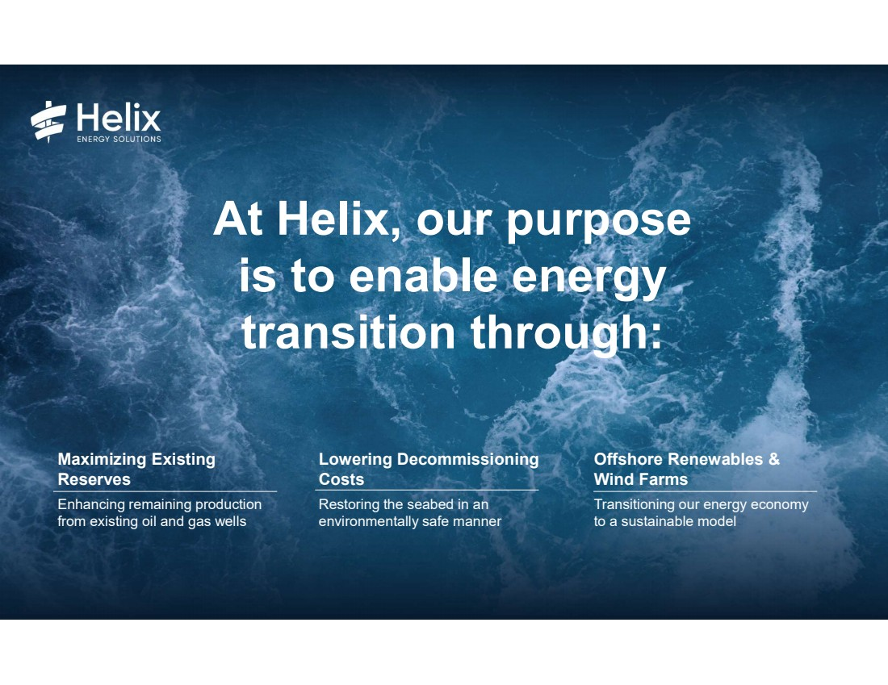 | At Helix, our purpose is to enable energy transition through: Maximizing Existing Reserves Enhancing remaining production from existing oil and gas wells Lowering Decommissioning Costs Restoring the seabed in an environmentally safe manner Offshore Renewables & Wind Farms Transitioning our energy economy to a sustainable model
4 4 ABOUT US 2024 Helix At A Glance We are an international offshore energy services company that provides specialty services to the offshore energy industry, with a focus on well intervention, robotics and full-field decommissioning operations. Our services are key in supporting a Global energy transition by:• Maximizing production of existing oil and gas reserves • Decommissioning end-of-life oil and gas fields and • Supporting renewable energy developments We provide our specialty services through our four business segments: • Well Intervention • Robotics • Shallow Water Abandonment • Production Facilities 7 5 12 47 5 Well Intervention Vessels Seven dedicated well intervention vessels ROV Support Vessels Five ROV support vessels on term charters Intervention Systems Eight intervention riser systems, three subsea intervention lubricators, and one riserless openwater abandonment module Robotics Assets Six trenching systems, two IROV boulder grabs and 39 work class ROVs Regional Offices Houston, Texas, USA (HQ) Aberdeen, United Kingdom Rio de Janeiro, Brazil Singapore Houma, Louisiana 20 Shallow Water Abandonment Vessels Nine liftboats, six OSVs, three diving vessels, one heavy lift barge and one crewboat 27 Shallow Water Abandonment Systems 20 P&A systems, six coiled tubing systems and one snubbing unit
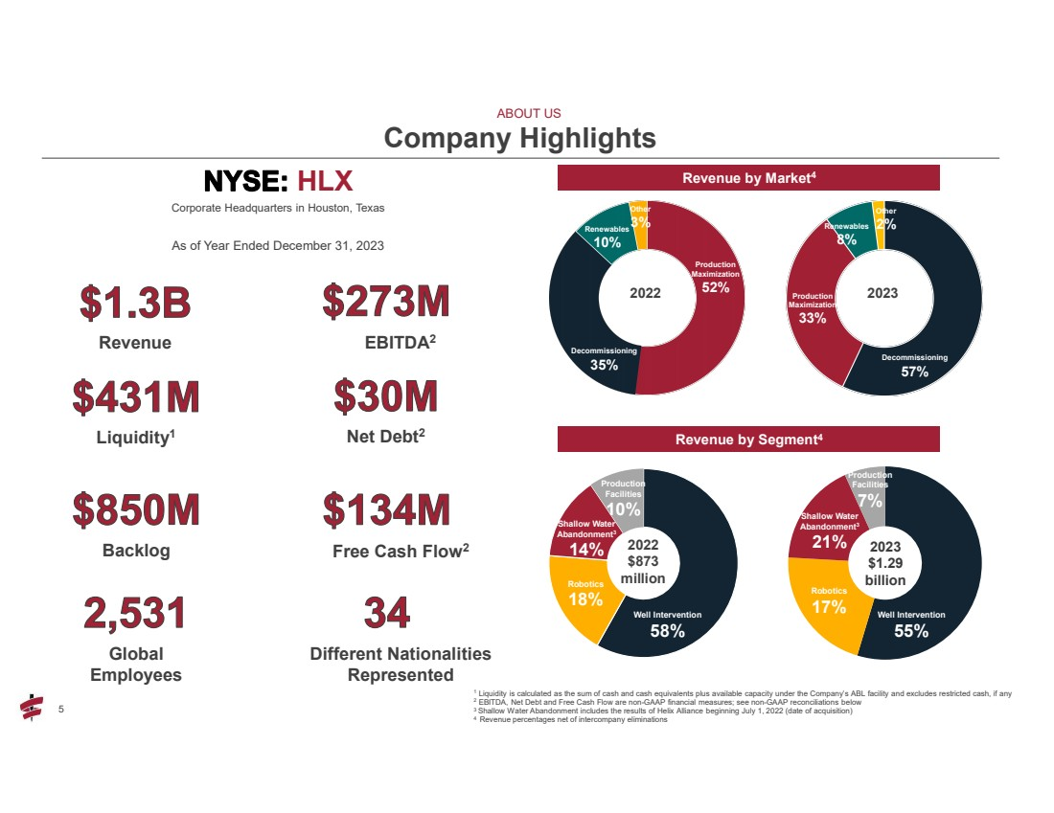 | 5 EBITDA2 Company Highlights 1 Liquidity is calculated as the sum of cash and cash equivalents plus available capacity under the Company’s ABL facility and excludes restricted cash, if any 2 EBITDA, Net Debt and Free Cash Flow are non-GAAP financial measures; see non-GAAP reconciliations below 3 Shallow Water Abandonment includes the results of Helix Alliance beginning July 1, 2022 (date of acquisition) 4 Revenue percentages net of intercompany eliminations Revenue by Market4 ABOUT US Revenue by Segment4 Renewables 10% 2022 Decommissioning 35% Production Maximization 52% Other 3% Renewables 8% Decommissioning 57% Production Maximization 33% Other 2% Well Intervention 58% Robotics 18% Shallow Water Abandonment3 14% Production Facilities 10% 2022 $873 million Shallow Water Abandonment3 21% Robotics 17% 2023 $1.29 billion Production Facilities 7% Well Intervention 55% Upcoming Deposits Global Employees Revenue Liquidity1 Backlog Different Nationalities Represented Net Debt2 HLX Corporate Headquarters in Houston, Texas As of Year Ended December 31, 2023 Free Cash Flow2 2023
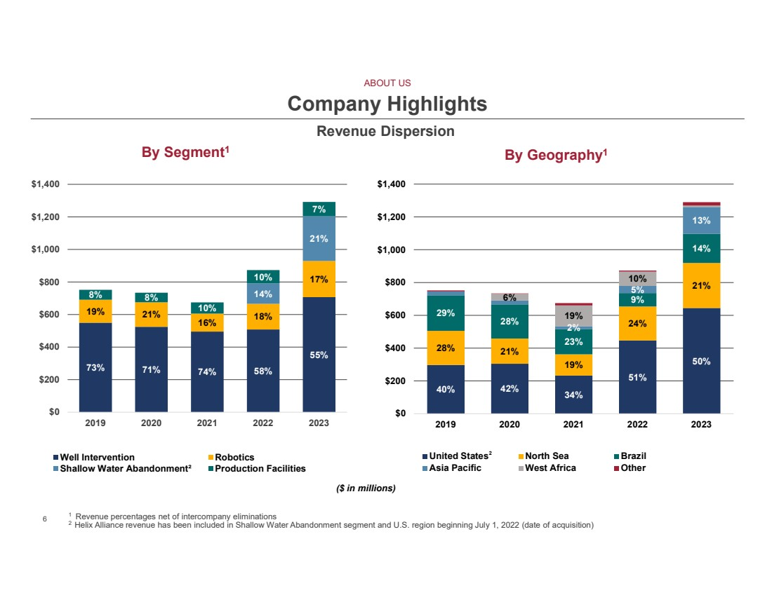 | 6 6 Company Highlights By Geography By Segment 1 1 1 Revenue percentages net of intercompany eliminations 2 Helix Alliance revenue has been included in Shallow Water Abandonment segment and U.S. region beginning July 1, 2022 (date of acquisition) 73% 71% 74% 58% 55% 19% 21% 16% 18% 17% 14% 21% 8% 8% 10% 10% 7% $0 $200 $400 $600 $800 $1,000 $1,200 $1,400 2019 2020 2021 2022 2023 Well Intervention Robotics Shallow Water Abandonment² Production Facilities 40% 42% 34% 51% 50% 28% 21% 19% 24% 21% 29% 28% 23% 9% 14% 2% 5% 13% 6% 19% 10% $0 $200 $400 $600 $800 $1,000 $1,200 $1,400 2019 2020 2021 2022 2023 United States North Sea Brazil Asia Pacific West Africa Other ABOUT US ($ in millions) 2 Revenue Dispersion
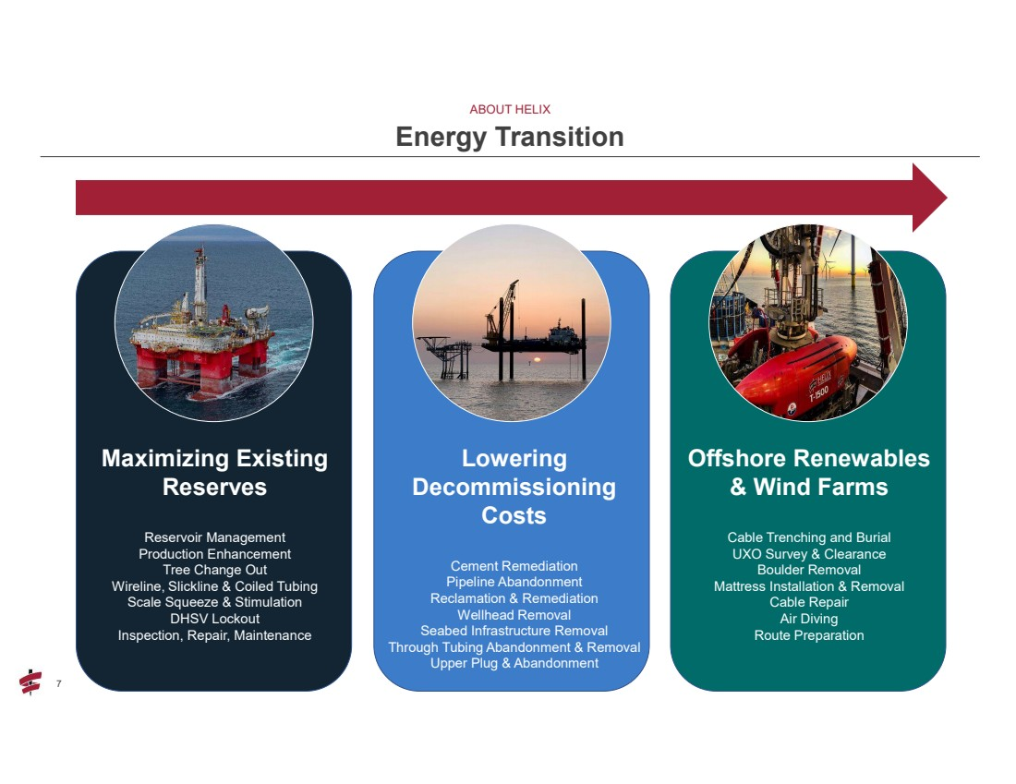 | 7 7 ABOUT HELIX Energy Transition Maximizing Existing Reserves Reservoir Management Production Enhancement Tree Change Out Wireline, Slickline & Coiled Tubing Scale Squeeze & Stimulation DHSV Lockout Inspection, Repair, Maintenance Lowering Decommissioning Costs Cement Remediation Pipeline Abandonment Reclamation & Remediation Wellhead Removal Seabed Infrastructure Removal Through Tubing Abandonment & Removal Upper Plug & Abandonment Offshore Renewables & Wind Farms Cable Trenching and Burial UXO Survey & Clearance Boulder Removal Mattress Installation & Removal Cable Repair Air Diving Route Preparation
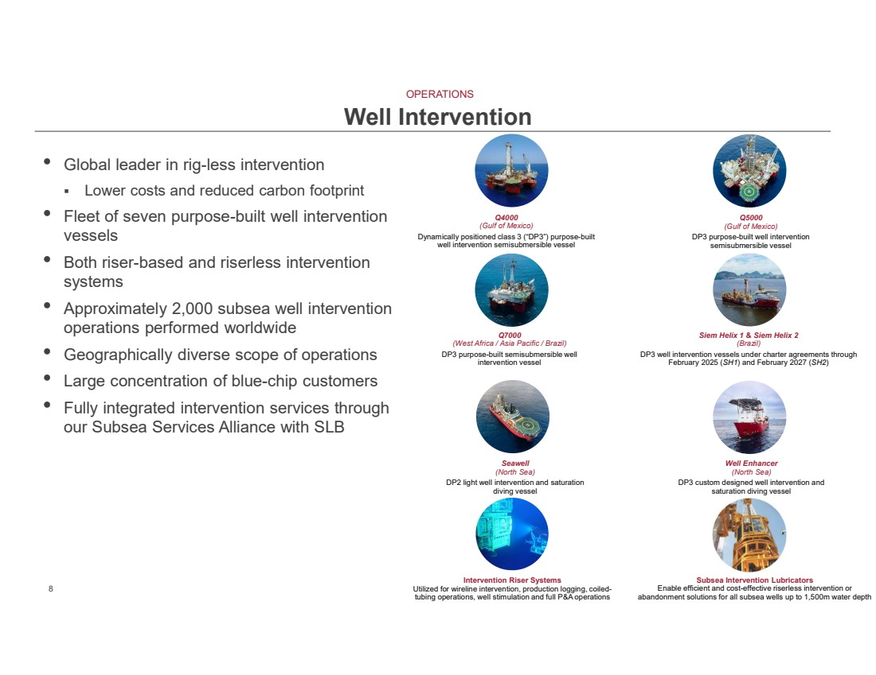 | 8 • Global leader in rig-less intervention ▪ Lower costs and reduced carbon footprint • Fleet of seven purpose-built well intervention vessels • Both riser-based and riserless intervention systems • Approximately 2,000 subsea well intervention operations performed worldwide • Geographically diverse scope of operations • Large concentration of blue-chip customers • Fully integrated intervention services through our Subsea Services Alliance with SLB Well Intervention Q4000 (Gulf of Mexico) Dynamically positioned class 3 (“DP3”) purpose-built well intervention semisubmersible vessel Q5000 (Gulf of Mexico) DP3 purpose-built well intervention semisubmersible vessel Q7000 (West Africa / Asia Pacific / Brazil) DP3 purpose-built semisubmersible well intervention vessel Siem Helix 1 & Siem Helix 2 (Brazil) DP3 well intervention vessels under charter agreements through February 2025 (SH1) and February 2027 (SH2) Seawell (North Sea) DP2 light well intervention and saturation diving vessel Well Enhancer (North Sea) DP3 custom designed well intervention and saturation diving vessel Intervention Riser Systems Utilized for wireline intervention, production logging, coiled-tubing operations, well stimulation and full P&A operations Subsea Intervention Lubricators Enable efficient and cost-effective riserless intervention or abandonment solutions for all subsea wells up to 1,500m water depth OPERATIONS
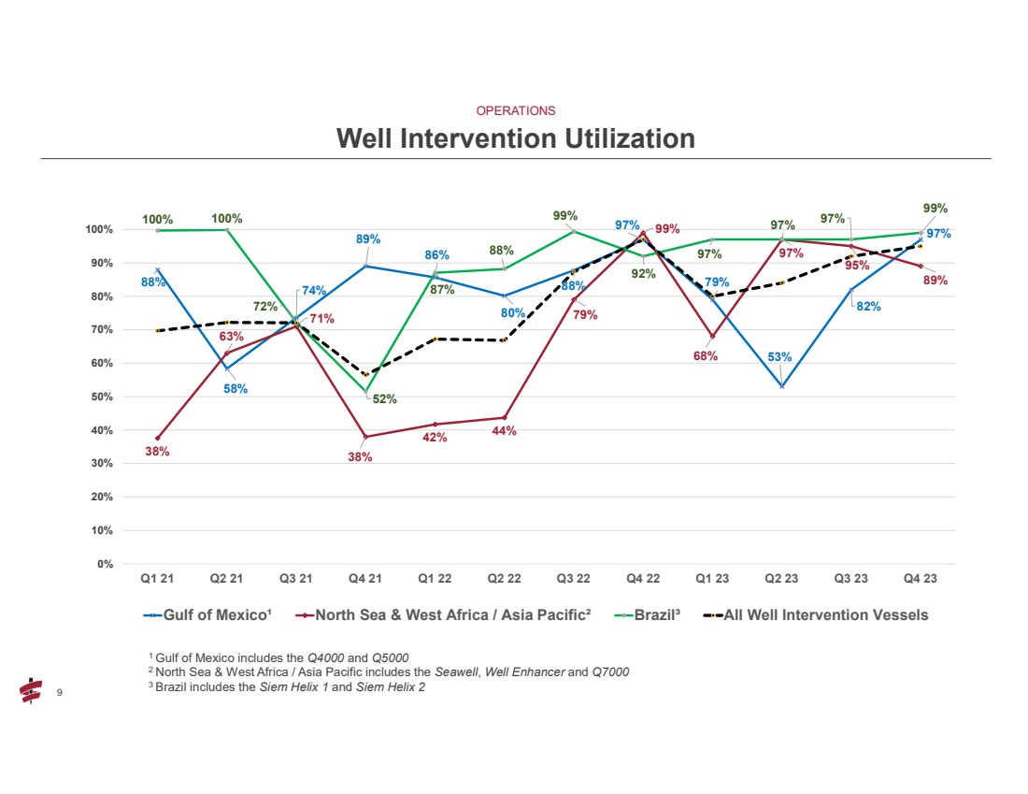 | 9 9 Well Intervention Utilization 88% 58% 74% 89% 86% 80% 88% 97% 79% 53% 82% 97% 38% 63% 71% 38% 42% 44% 79% 99% 68% 97% 95% 89% 100% 100% 72% 52% 87% 88% 99% 92% 97% 97% 97% 99% 0% 10% 20% 30% 40% 50% 60% 70% 80% 90% 100% Q1 21 Q2 21 Q3 21 Q4 21 Q1 22 Q2 22 Q3 22 Q4 22 Q1 23 Q2 23 Q3 23 Q4 23 Gulf of Mexico¹ North Sea & West Africa / Asia Pacific² Brazil³ All Well Intervention Vessels 1 Gulf of Mexico includes the Q4000 and Q5000 2 North Sea & West Africa / Asia Pacific includes the Seawell, Well Enhancer and Q7000 3 Brazil includes the Siem Helix 1 and Siem Helix 2 OPERATIONS
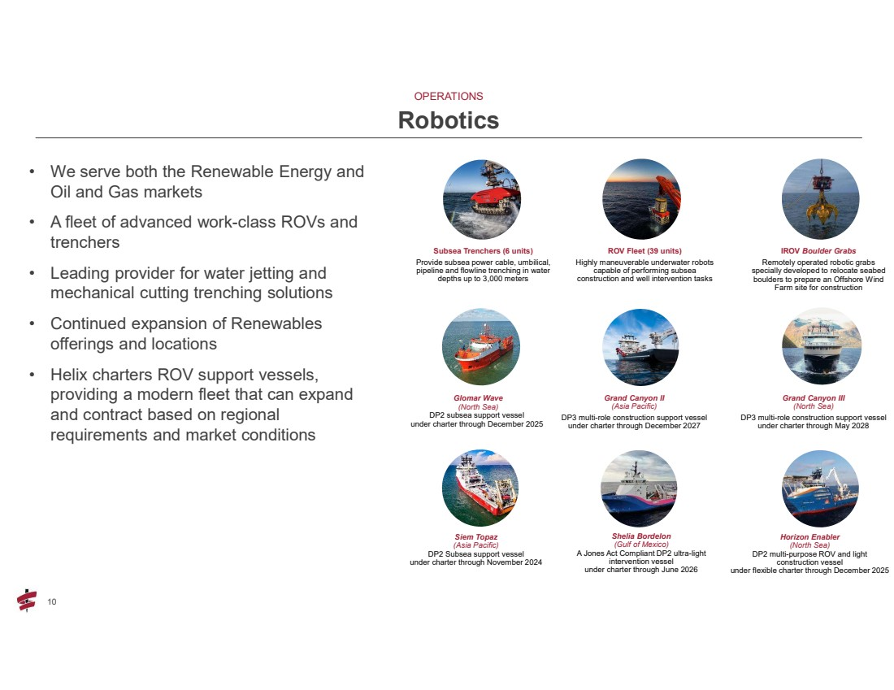 | 10 10 • We serve both the Renewable Energy and Oil and Gas markets • A fleet of advanced work-class ROVs and trenchers • Leading provider for water jetting and mechanical cutting trenching solutions • Continued expansion of Renewables offerings and locations • Helix charters ROV support vessels, providing a modern fleet that can expand and contract based on regional requirements and market conditions Robotics ROV Fleet (39 units) Highly maneuverable underwater robots capable of performing subsea construction and well intervention tasks Subsea Trenchers (6 units) Provide subsea power cable, umbilical, pipeline and flowline trenching in water depths up to 3,000 meters IROV Boulder Grabs Remotely operated robotic grabs specially developed to relocate seabed boulders to prepare an Offshore Wind Farm site for construction Glomar Wave (North Sea) DP2 subsea support vessel under charter through December 2025 Grand Canyon II (Asia Pacific) DP3 multi-role construction support vessel under charter through December 2027 Grand Canyon III (North Sea) DP3 multi-role construction support vessel under charter through May 2028 Shelia Bordelon (Gulf of Mexico) A Jones Act Compliant DP2 ultra-light intervention vessel under charter through June 2026 Horizon Enabler (North Sea) DP2 multi-purpose ROV and light construction vessel under flexible charter through December 2025 Siem Topaz (Asia Pacific) DP2 Subsea support vessel under charter through November 2024 OPERATIONS
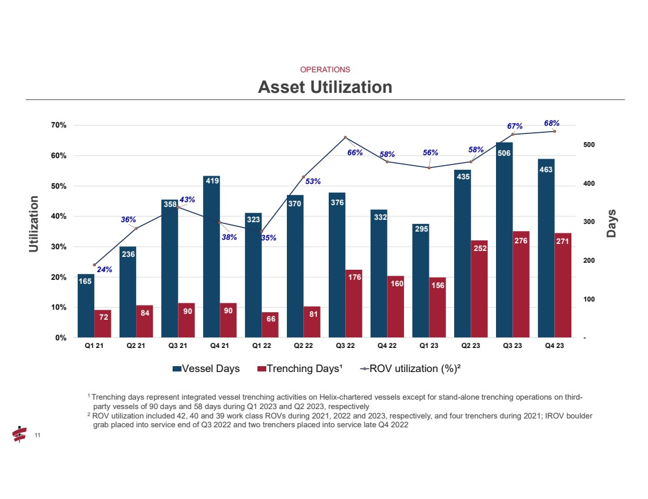 | 11 11 Asset Utilization 165 236 358 419 323 370 376 332 295 435 506 463 72 84 90 90 66 81 176 160 156 252 276 271 24% 36% 43% 38% 35% 53% 66% 58% 56% 58% 67% 68% - 100 200 300 400 500 0% 10% 20% 30% 40% 50% 60% 70% Q1 21 Q2 21 Q3 21 Q4 21 Q1 22 Q2 22 Q3 22 Q4 22 Q1 23 Q2 23 Q3 23 Q4 23 Vessel Days Trenching Days¹ ROV utilization (%)² 1 Trenching days represent integrated vessel trenching activities on Helix-chartered vessels except for stand-alone trenching operations on third-party vessels of 90 days and 58 days during Q1 2023 and Q2 2023, respectively 2 ROV utilization included 42, 40 and 39 work class ROVs during 2021, 2022 and 2023, respectively, and four trenchers during 2021; IROV boulder grab placed into service end of Q3 2022 and two trenchers placed into service late Q4 2022 Utilization Days OPERATIONS
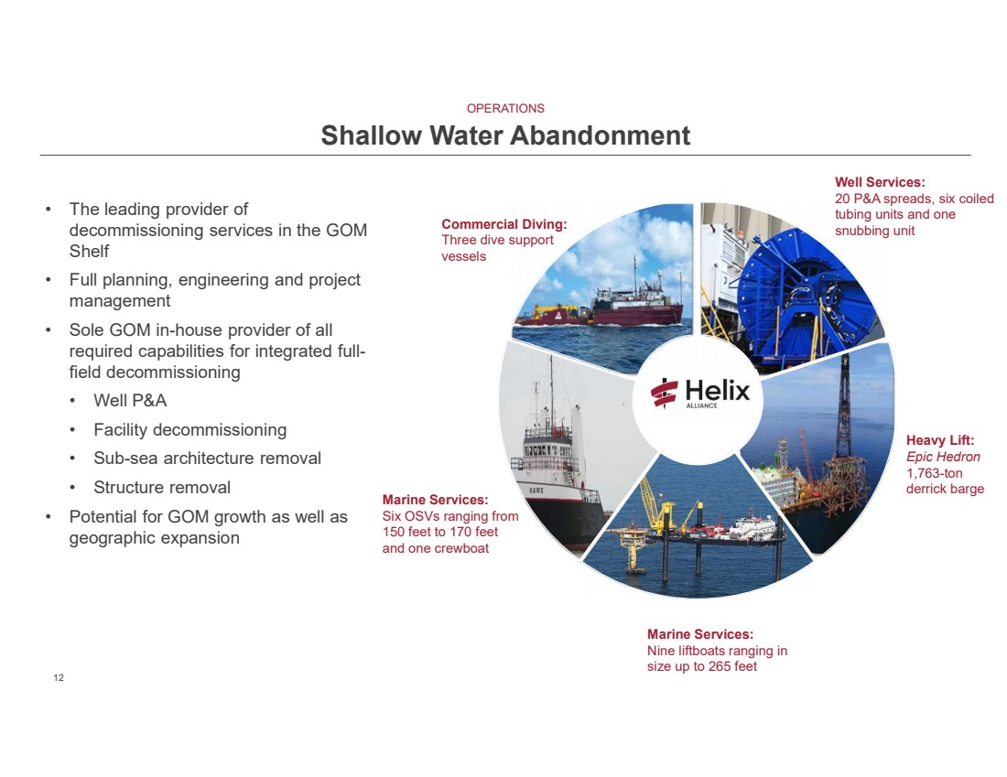 | 12 12 • The leading provider of decommissioning services in the GOM Shelf • Full planning, engineering and project management • Sole GOM in-house provider of all required capabilities for integrated full-field decommissioning • Well P&A • Facility decommissioning • Sub-sea architecture removal • Structure removal • Potential for GOM growth as well as geographic expansion OPERATIONS Shallow Water Abandonment Commercial Diving: Three dive support vessels Well Services: 20 P&A spreads, six coiled tubing units and one snubbing unit Marine Services: Six OSVs ranging from 150 feet to 170 feet and one crewboat Heavy Lift: Epic Hedron 1,763-ton derrick barge Marine Services: Nine liftboats ranging in size up to 265 feet
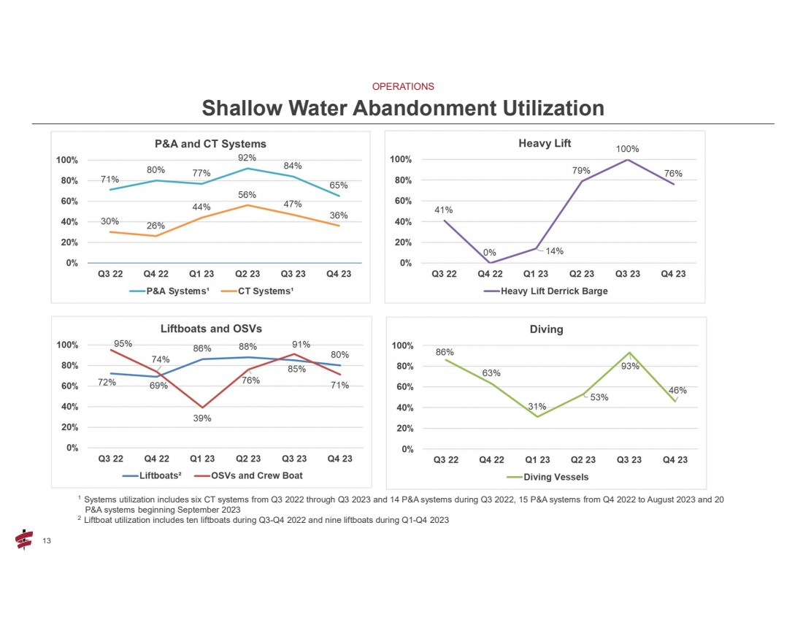 | 13 13 Shallow Water Abandonment Utilization 1 Systems utilization includes six CT systems from Q3 2022 through Q3 2023 and 14 P&A systems during Q3 2022, 15 P&A systems from Q4 2022 to August 2023 and 20 P&A systems beginning September 2023 2 Liftboat utilization includes ten liftboats during Q3-Q4 2022 and nine liftboats during Q1-Q4 2023 OPERATIONS
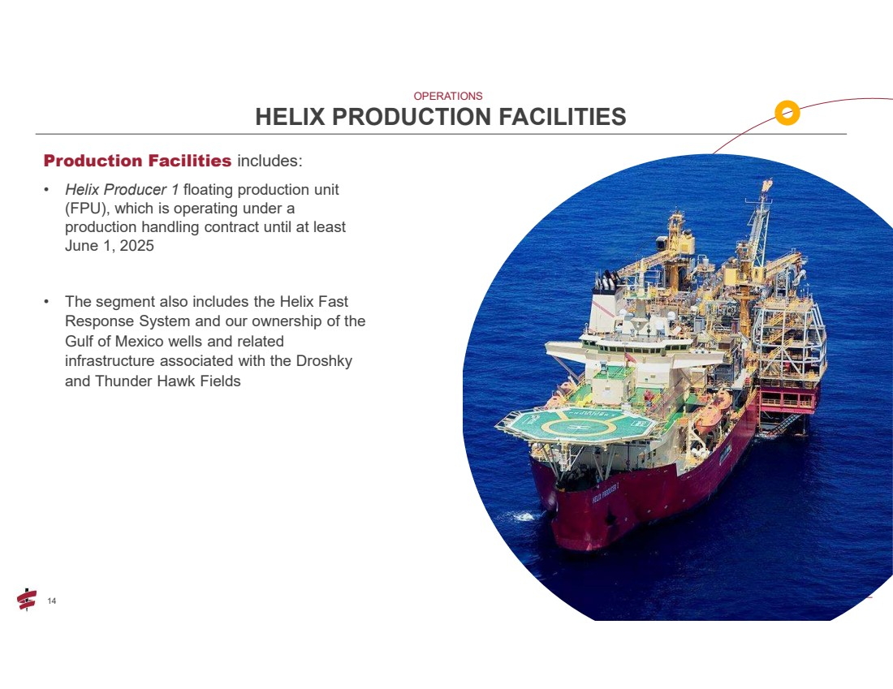 | 14 Production Facilities includes: • Helix Producer 1 floating production unit (FPU), which is operating under a production handling contract until at least June 1, 2025 • The segment also includes the Helix Fast Response System and our ownership of the Gulf of Mexico wells and related infrastructure associated with the Droshky and Thunder Hawk Fields HELIX PRODUCTION FACILITIES OPERATIONS
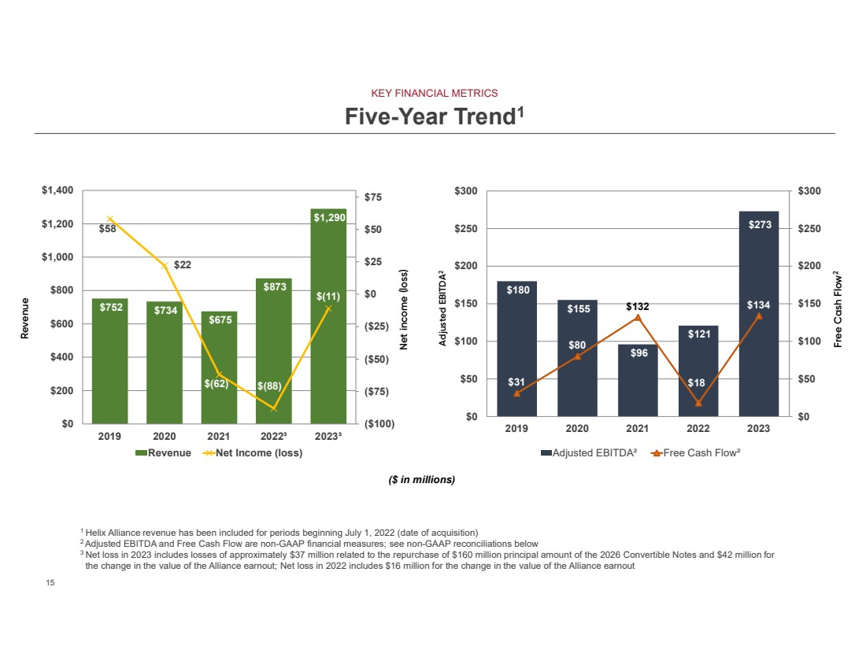 | 15 15 Five-Year Trend1 Revenue Free Cash Flow2 $752 $734 $675 $873 $1,290 $58 $22 $(62) $(88) $(11) ($100) ($75) ($50) ($25) $0 $25 $50 $75 $0 $200 $400 $600 $800 $1,000 $1,200 $1,400 2019 2020 2021 2022³ 2023³ Revenue Net Income (loss) Net income (loss) Adjusted EBITDA2 $180 $155 $96 $121 $273 $31 $80 $132 $18 $134 $0 $50 $100 $150 $200 $250 $300 $0 $50 $100 $150 $200 $250 $300 2019 2020 2021 2022 2023 Adjusted EBITDA² Free Cash Flow² 1 Helix Alliance revenue has been included for periods beginning July 1, 2022 (date of acquisition) 2 Adjusted EBITDA and Free Cash Flow are non-GAAP financial measures; see non-GAAP reconciliations below 3 Net loss in 2023 includes losses of approximately $37 million related to the repurchase of $160 million principal amount of the 2026 Convertible Notes and $42 million for the change in the value of the Alliance earnout; Net loss in 2022 includes $16 million for the change in the value of the Alliance earnout KEY FINANCIAL METRICS ($ in millions)
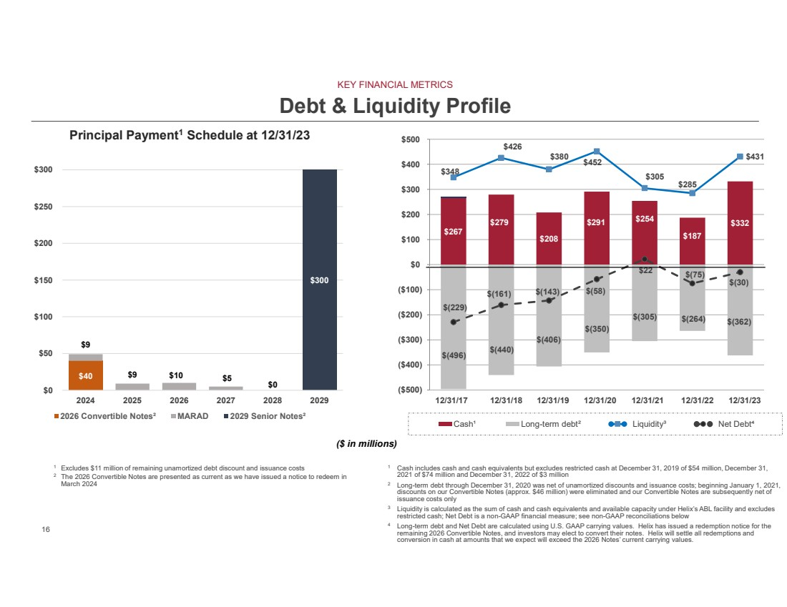 | 16 16 $267 $279 $208 $291 $254 $187 $332 $(496) $(440) $(406) $(350) $(305) $(264) $(362) $348 $426 $380 $452 $305 $285 $431 $(229) $(161) $(143) $(58) $22 $(75) $(30) ($500) ($400) ($300) ($200) ($100) $0 $100 $200 $300 $400 $500 Cash¹ Long-term debt² Liquidity³ Net Debt⁴ Debt & Liquidity Profile 1 Cash includes cash and cash equivalents but excludes restricted cash at December 31, 2019 of $54 million, December 31, 2021 of $74 million and December 31, 2022 of $3 million 2 Long-term debt through December 31, 2020 was net of unamortized discounts and issuance costs; beginning January 1, 2021, discounts on our Convertible Notes (approx. $46 million) were eliminated and our Convertible Notes are subsequently net of issuance costs only 3 Liquidity is calculated as the sum of cash and cash equivalents and available capacity under Helix’s ABL facility and excludes restricted cash; Net Debt is a non-GAAP financial measure; see non-GAAP reconciliations below 4 Long-term debt and Net Debt are calculated using U.S. GAAP carrying values. Helix has issued a redemption notice for the remaining 2026 Convertible Notes, and investors may elect to convert their notes. Helix will settle all redemptions and conversion in cash at amounts that we expect will exceed the 2026 Notes’ current carrying values. 12/31/17 12/31/18 12/31/19 12/31/20 12/31/21 12/31/22 12/31/23 $40 $0 $9 $9 $10 $5 $300 $0 $50 $100 $150 $200 $250 $300 2024 2025 2026 2027 2028 2029 Principal Payment1 Schedule at 12/31/23 2026 Convertible Notes² MARAD 2029 Senior Notes² 1 Excludes $11 million of remaining unamortized debt discount and issuance costs 2 The 2026 Convertible Notes are presented as current as we have issued a notice to redeem in March 2024 KEY FINANCIAL METRICS ($ in millions)
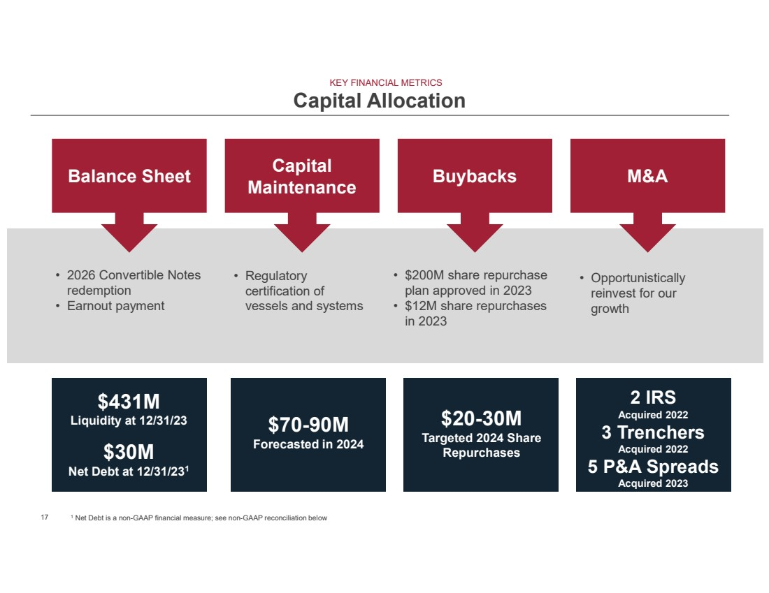 | 17 Capital Allocation Buybacks • $200M share repurchase plan approved in 2023 • $12M share repurchases in 2023 M&A • Opportunistically reinvest for our growth Capital Maintenance • Regulatory certification of vessels and systems Balance Sheet • 2026 Convertible Notes redemption • Earnout payment $431M Liquidity at 12/31/23 $30M Net Debt at 12/31/231 $20-30M Targeted 2024 Share Repurchases $70-90M Forecasted in 2024 2 IRS Acquired 2022 3 Trenchers Acquired 2022 5 P&A Spreads Acquired 2023 KEY FINANCIAL METRICS 1 Net Debt is a non-GAAP financial measure; see non-GAAP reconciliation below
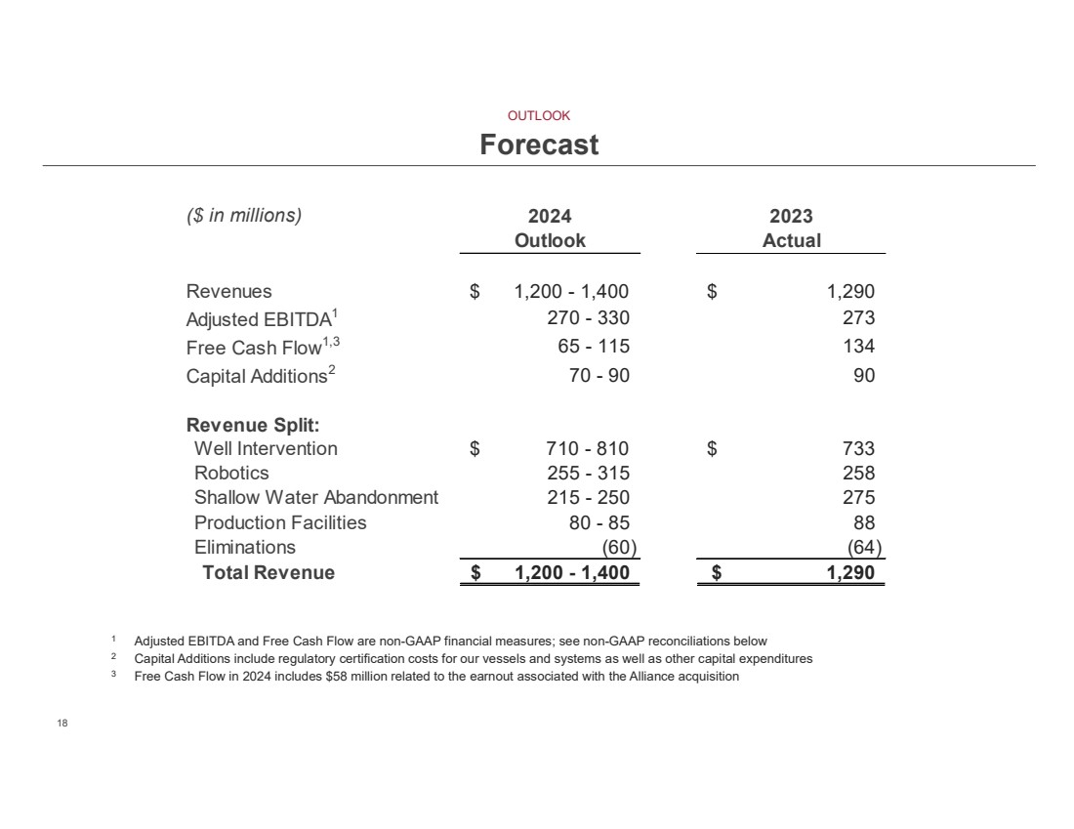 | 18 18 Forecast ($ in millions) 2024 2023 Outlook Actual Revenues $ 1,200 - 1,400 1,290 $ Adjusted EBITDA1 270 - 330 273 Free Cash Flow1,3 65 - 115 134 Capital Additions2 70 - 90 90 Revenue Split: Well Intervention $ 710 - 810 733 $ Robotics 255 - 315 258 Shallow Water Abandonment 215 - 250 275 Production Facilities 80 - 85 88 Eliminations (64) (60) Total Revenue $ 1,200 - 1,400 1,290 $ 1 Adjusted EBITDA and Free Cash Flow are non-GAAP financial measures; see non-GAAP reconciliations below 2 Capital Additions include regulatory certification costs for our vessels and systems as well as other capital expenditures 3 Free Cash Flow in 2024 includes $58 million related to the earnout associated with the Alliance acquisition OUTLOOK
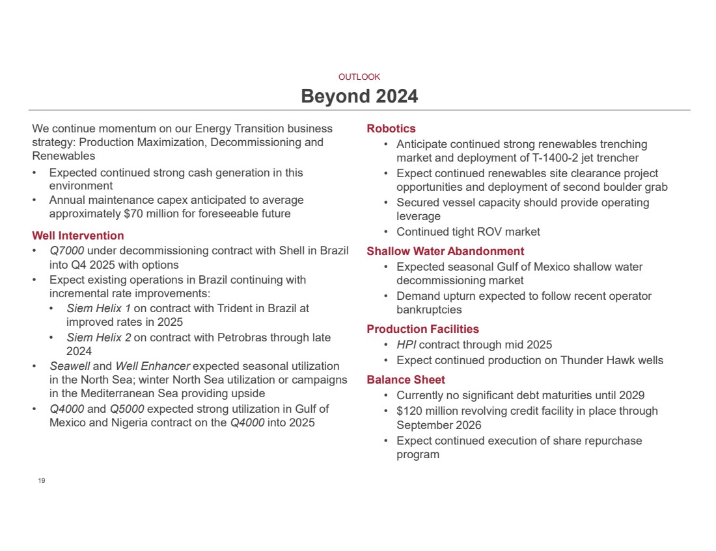 | 19 19 We continue momentum on our Energy Transition business strategy: Production Maximization, Decommissioning and Renewables • Expected continued strong cash generation in this environment • Annual maintenance capex anticipated to average approximately $70 million for foreseeable future Well Intervention • Q7000 under decommissioning contract with Shell in Brazil into Q4 2025 with options • Expect existing operations in Brazil continuing with incremental rate improvements: • Siem Helix 1 on contract with Trident in Brazil at improved rates in 2025 • Siem Helix 2 on contract with Petrobras through late 2024 • Seawell and Well Enhancer expected seasonal utilization in the North Sea; winter North Sea utilization or campaigns in the Mediterranean Sea providing upside • Q4000 and Q5000 expected strong utilization in Gulf of Mexico and Nigeria contract on the Q4000 into 2025 Robotics • Anticipate continued strong renewables trenching market and deployment of T-1400-2 jet trencher • Expect continued renewables site clearance project opportunities and deployment of second boulder grab • Secured vessel capacity should provide operating leverage • Continued tight ROV market Shallow Water Abandonment • Expected seasonal Gulf of Mexico shallow water decommissioning market • Demand upturn expected to follow recent operator bankruptcies Production Facilities • HPI contract through mid 2025 • Expect continued production on Thunder Hawk wells Balance Sheet • Currently no significant debt maturities until 2029 • $120 million revolving credit facility in place through September 2026 • Expect continued execution of share repurchase program Beyond 2024 OUTLOOK
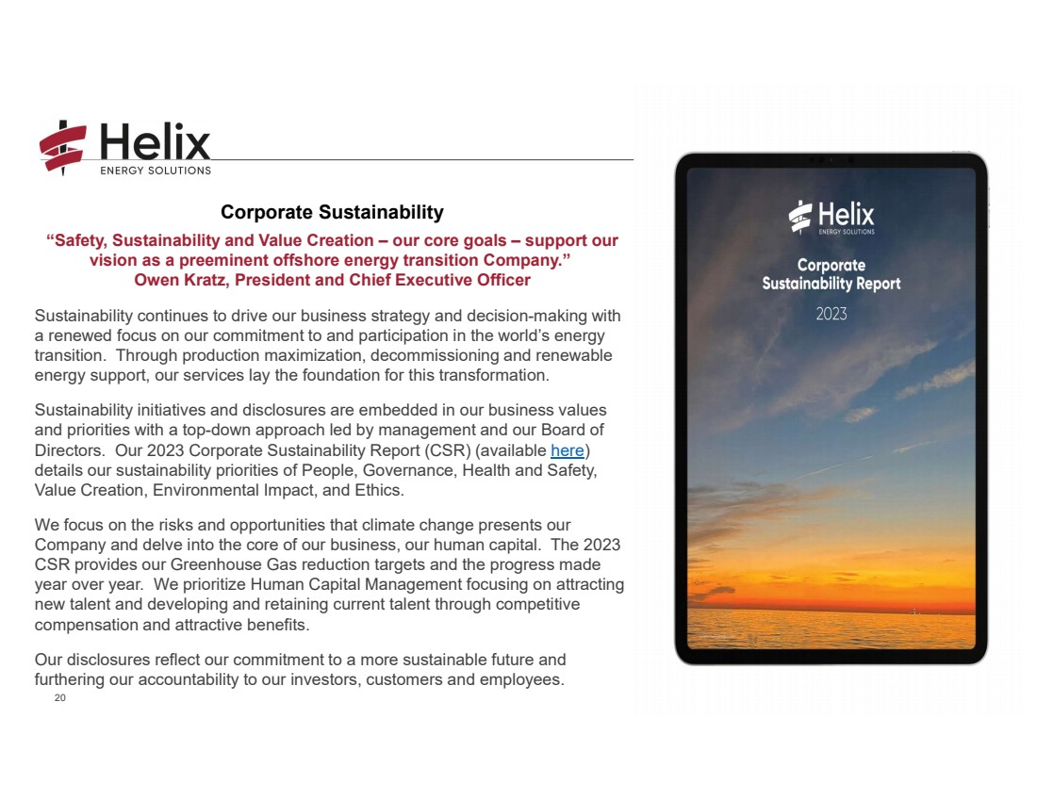 | 20 20 Corporate Sustainability “Safety, Sustainability and Value Creation – our core goals – support our vision as a preeminent offshore energy transition Company.” Owen Kratz, President and Chief Executive Officer Sustainability continues to drive our business strategy and decision-making with a renewed focus on our commitment to and participation in the world’s energy transition. Through production maximization, decommissioning and renewable energy support, our services lay the foundation for this transformation. Sustainability initiatives and disclosures are embedded in our business values and priorities with a top-down approach led by management and our Board of Directors. Our 2023 Corporate Sustainability Report (CSR) (available here) details our sustainability priorities of People, Governance, Health and Safety, Value Creation, Environmental Impact, and Ethics. We focus on the risks and opportunities that climate change presents our Company and delve into the core of our business, our human capital. The 2023 CSR provides our Greenhouse Gas reduction targets and the progress made year over year. We prioritize Human Capital Management focusing on attracting new talent and developing and retaining current talent through competitive compensation and attractive benefits. Our disclosures reflect our commitment to a more sustainable future and furthering our accountability to our investors, customers and employees.
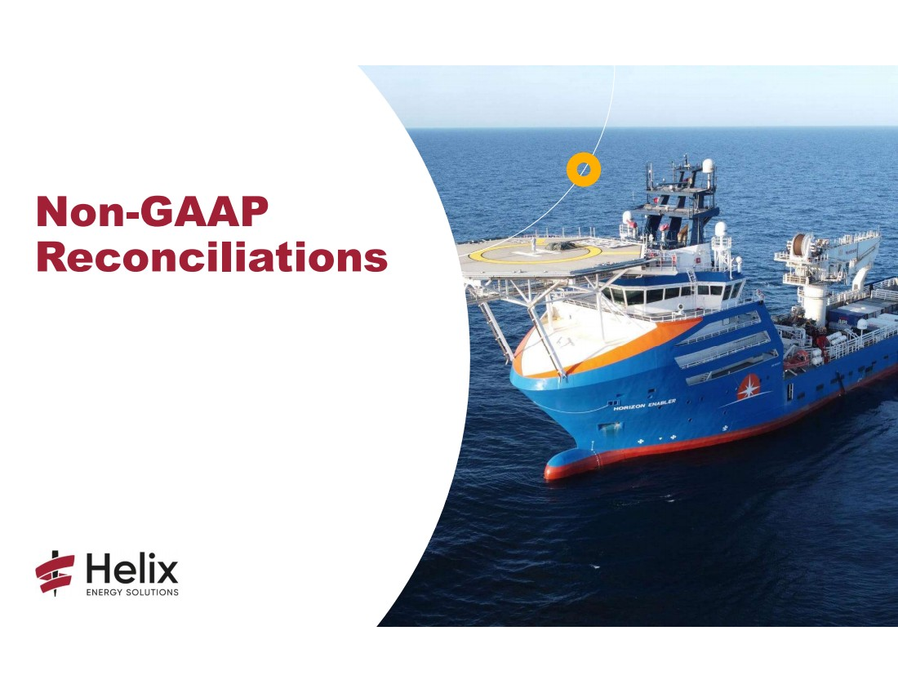 | Non-GAAP Reconciliations
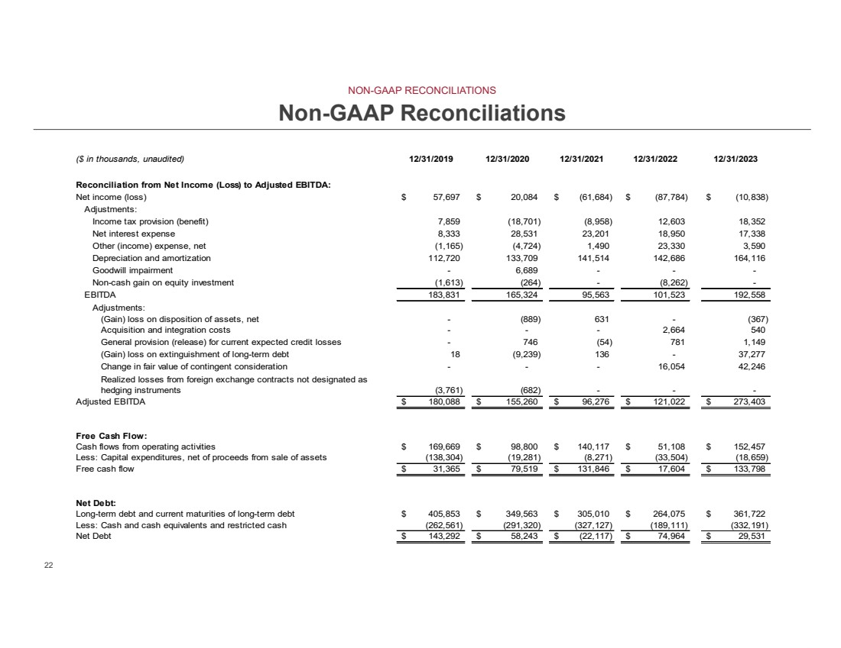 | 22 22 Non-GAAP Reconciliations ($ in thousands, unaudited) 12/31/2019 12/31/2020 12/31/2021 12/31/2022 12/31/2023 Reconciliation from Net Income (Loss) to Adjusted EBITDA: Net income (loss) 57,697 $ 20,084 $ (61,684) $ (87,784) $ (10,838) $ Adjustments: Income tax provision (benefit) 7,859 (18,701) (8,958) 12,603 18,352 Net interest expense 8,333 28,531 23,201 18,950 17,338 Other (income) expense, net (1,165) (4,724) 1,490 23,330 3,590 Depreciation and amortization 112,720 133,709 141,514 142,686 164,116 Goodwill impairment - 6,689 - - - Non-cash gain on equity investment (1,613) (264) - (8,262) - EBITDA 183,831 165,324 95,563 101,523 192,558 Adjustments: (Gain) loss on disposition of assets, net - (889) 631 - (367) Acquisition and integration costs - - - 2,664 540 General provision (release) for current expected credit losses - 746 (54) 781 1,149 (Gain) loss on extinguishment of long-term debt 18 (9,239) 136 - 37,277 Change in fair value of contingent consideration - - - 16,054 42,246 Realized losses from foreign exchange contracts not designated as hedging instruments (3,761) (682) - - - Adjusted EBITDA 180,088 $ 155,260 $ 96,276 $ 121,022 $ 273,403 $ Free Cash Flow: Cash flows from operating activities 169,669 $ 98,800 $ 140,117 $ 51,108 $ 152,457 $ Less: Capital expenditures, net of proceeds from sale of assets (138,304) (19,281) (8,271) (33,504) (18,659) Free cash flow 31,365 $ 79,519 $ 131,846 $ 17,604 $ 133,798 $ Net Debt: Long-term debt and current maturities of long-term debt 405,853 $ 349,563 $ 305,010 $ 264,075 $ 361,722 $ Less: Cash and cash equivalents and restricted cash (262,561) (291,320) (327,127) (189,111) (332,191) Net Debt 143,292 $ 58,243 $ (22,117) $ 74,964 $ 29,531 $ NON-GAAP RECONCILIATIONS
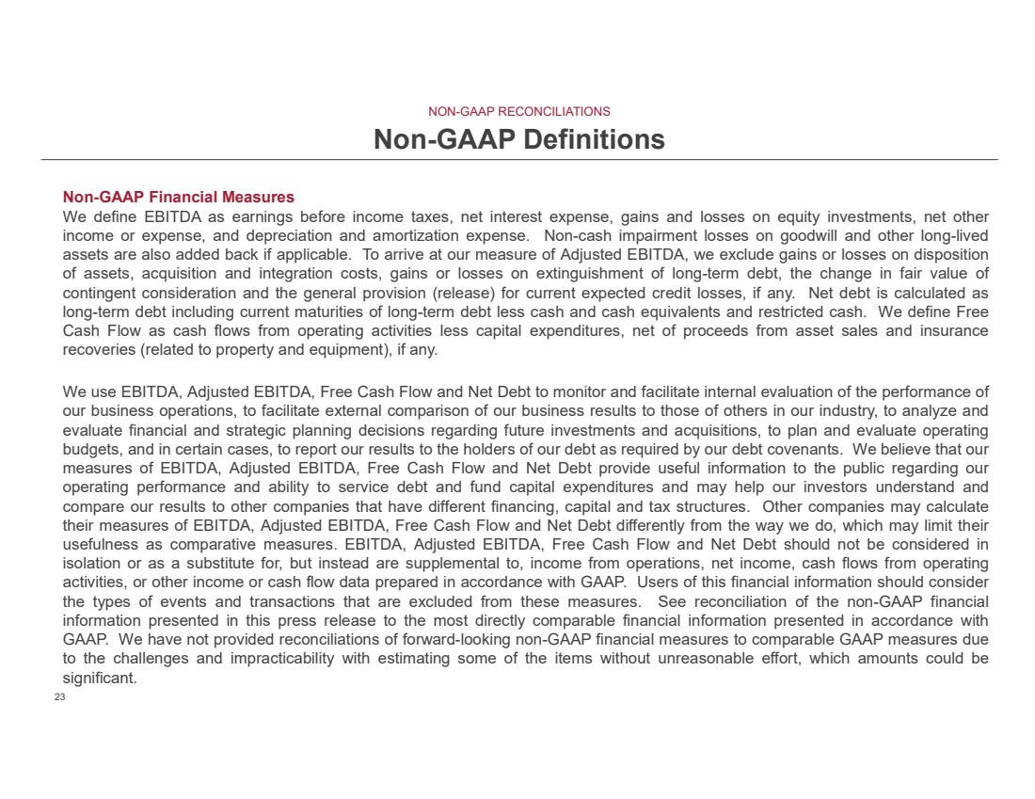 | 23 23 Non-GAAP Definitions Non-GAAP Financial Measures We define EBITDA as earnings before income taxes, net interest expense, gains and losses on equity investments, net other income or expense, and depreciation and amortization expense. Non-cash impairment losses on goodwill and other long-lived assets are also added back if applicable. To arrive at our measure of Adjusted EBITDA, we exclude gains or losses on disposition of assets, acquisition and integration costs, gains or losses on extinguishment of long-term debt, the change in fair value of contingent consideration and the general provision (release) for current expected credit losses, if any. Net debt is calculated as long-term debt including current maturities of long-term debt less cash and cash equivalents and restricted cash. We define Free Cash Flow as cash flows from operating activities less capital expenditures, net of proceeds from asset sales and insurance recoveries (related to property and equipment), if any. We use EBITDA, Adjusted EBITDA, Free Cash Flow and Net Debt to monitor and facilitate internal evaluation of the performance of our business operations, to facilitate external comparison of our business results to those of others in our industry, to analyze and evaluate financial and strategic planning decisions regarding future investments and acquisitions, to plan and evaluate operating budgets, and in certain cases, to report our results to the holders of our debt as required by our debt covenants. We believe that our measures of EBITDA, Adjusted EBITDA, Free Cash Flow and Net Debt provide useful information to the public regarding our operating performance and ability to service debt and fund capital expenditures and may help our investors understand and compare our results to other companies that have different financing, capital and tax structures. Other companies may calculate their measures of EBITDA, Adjusted EBITDA, Free Cash Flow and Net Debt differently from the way we do, which may limit their usefulness as comparative measures. EBITDA, Adjusted EBITDA, Free Cash Flow and Net Debt should not be considered in isolation or as a substitute for, but instead are supplemental to, income from operations, net income, cash flows from operating activities, or other income or cash flow data prepared in accordance with GAAP. Users of this financial information should consider the types of events and transactions that are excluded from these measures. See reconciliation of the non-GAAP financial information presented in this press release to the most directly comparable financial information presented in accordance with GAAP. We have not provided reconciliations of forward-looking non-GAAP financial measures to comparable GAAP measures due to the challenges and impracticability with estimating some of the items without unreasonable effort, which amounts could be significant. NON-GAAP RECONCILIATIONS
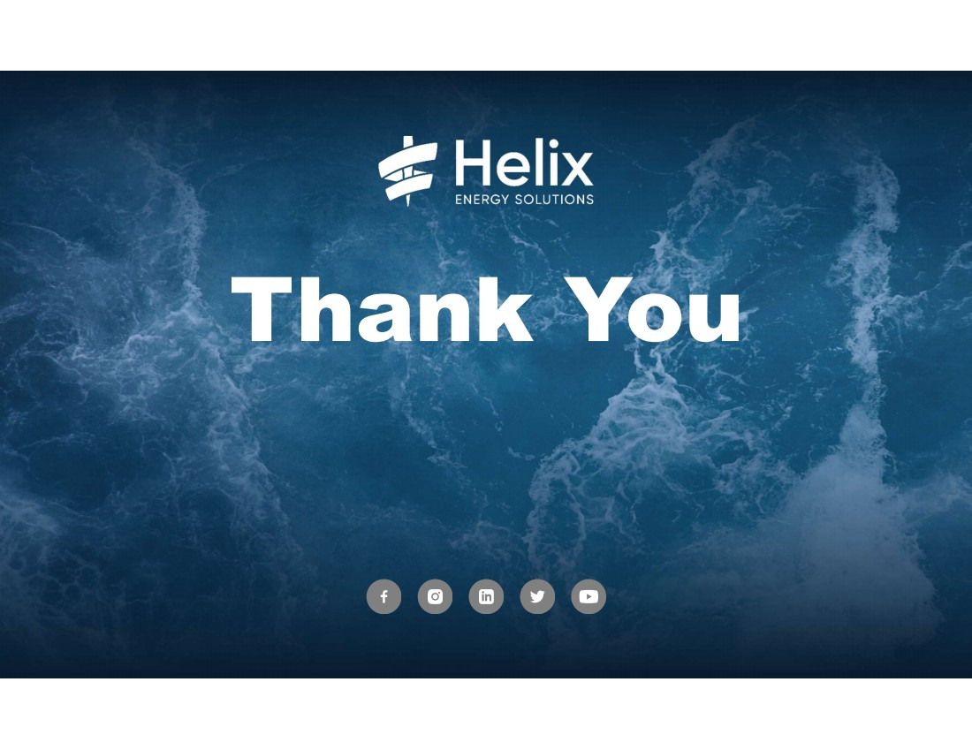 | 24 24
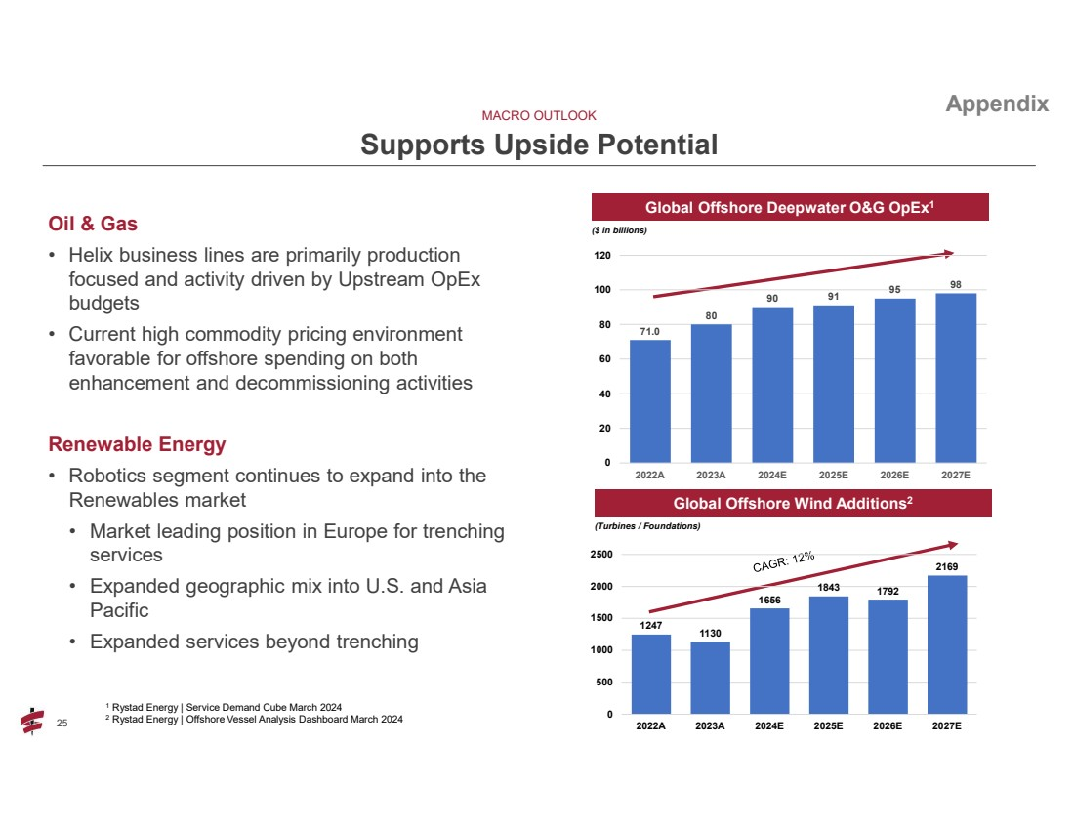 | 25 25 Oil & Gas • Helix business lines are primarily production focused and activity driven by Upstream OpEx budgets • Current high commodity pricing environment favorable for offshore spending on both enhancement and decommissioning activities Renewable Energy • Robotics segment continues to expand into the Renewables market • Market leading position in Europe for trenching services • Expanded geographic mix into U.S. and Asia Pacific • Expanded services beyond trenching MACRO OUTLOOK Supports Upside Potential Global Offshore Deepwater O&G OpEx1 ($ in billions) Global Offshore Wind Additions2 (Turbines / Foundations) 1 Rystad Energy | Service Demand Cube March 2024 2 Rystad Energy | Offshore Vessel Analysis Dashboard March 2024 Appendix 1247 1130 1656 1843 1792 2169 0 500 1000 1500 2000 2500 2022A 2023A 2024E 2025E 2026E 2027E 71.0 80 90 91 95 98 0 20 40 60 80 100 120 2022A 2023A 2024E 2025E 2026E 2027E
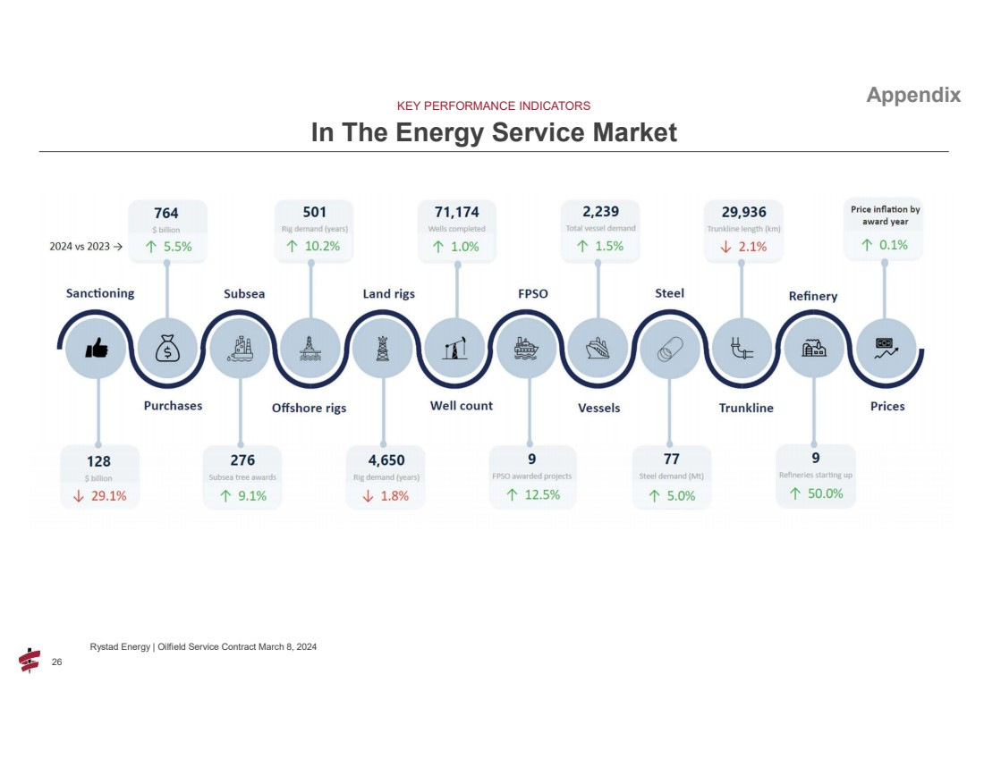 | 26 26 KEY PERFORMANCE INDICATORS In The Energy Service Market Rystad Energy | Oilfield Service Contract March 8, 2024 Appendix
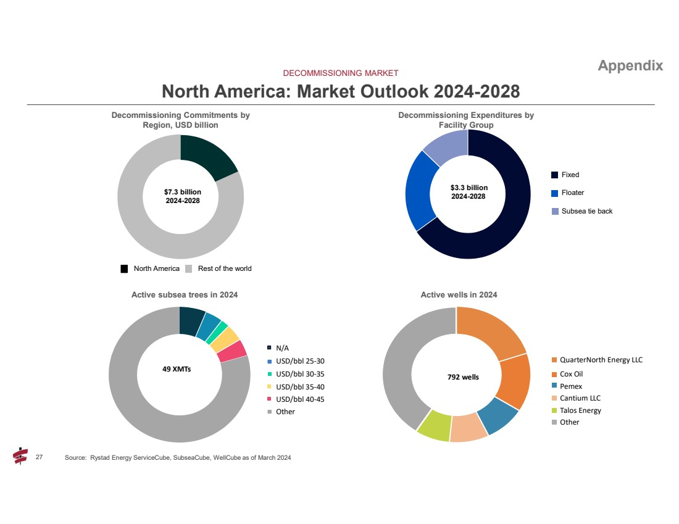 | 27 27 DECOMMISSIONING MARKET North America: Market Outlook 2024-2028 Source: Rystad Energy ServiceCube, SubseaCube, WellCube as of March 2024 Appendix Decommissioning Commitments by Region, USD billion $7.3 billion 2024-2028 North America Rest of the world Decommissioning Expenditures by Facility Group Fixed Floater Subsea tie back $3.3 billion 2024-2028 Active subsea trees in 2024 Active wells in 2024 792 wells 49 XMTs N/A USD/bbl 25-30 USD/bbl 30-35 USD/bbl 35-40 USD/bbl 40-45 Other QuarterNorth Energy LLC Cox Oil Pemex Cantium LLC Talos Energy Other
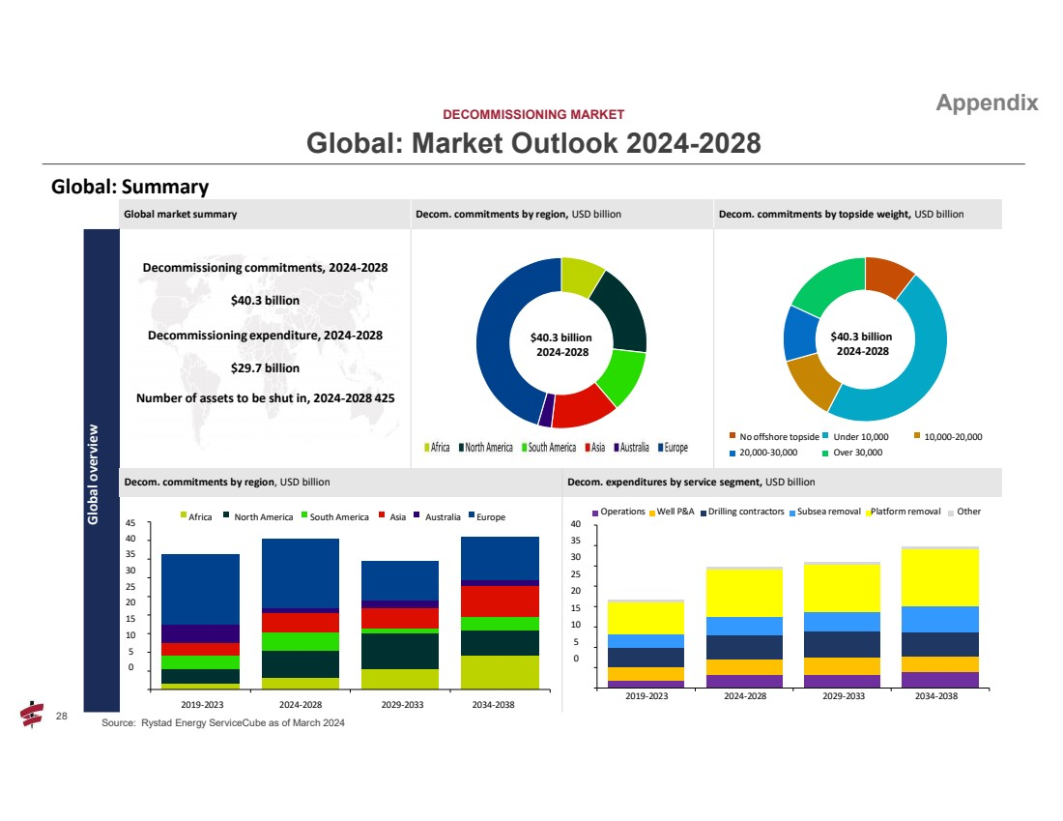 | 28 28 DECOMMISSIONING MARKET Global: Market Outlook 2024-2028 Source: Rystad Energy ServiceCube as of March 2024 Appendix Global: Summary Global market summary Decom. commitments by region, USD billion Decom. commitments by topside weight, USD billion Global overview Decommissioning commitments, 2024-2028 $40.3 billion Decommissioning expenditure, 2024-2028 $29.7 billion Number of assets to be shut in, 2024-2028 425 $40.3 billion 2024-2028 $40.3 billion 2024-2028 No offshore topside Under 10,000 10,000-20,000 20,000-30,000 Over 30,000 Decom. commitments by region, USD billion Decom. expenditures by service segment, USD billion Africa North America South America Asia Australia Europe 45 40 35 30 25 20 15 10 5 0 2019-2023 2024-2028 2029-2033 2034-2038 Operations Well P&A Drilling contractors Subsea removal Platform removal Other 40 35 30 25 20 15 10 5 0 2019-2023 2024-2028 2029-2033 2034-2038
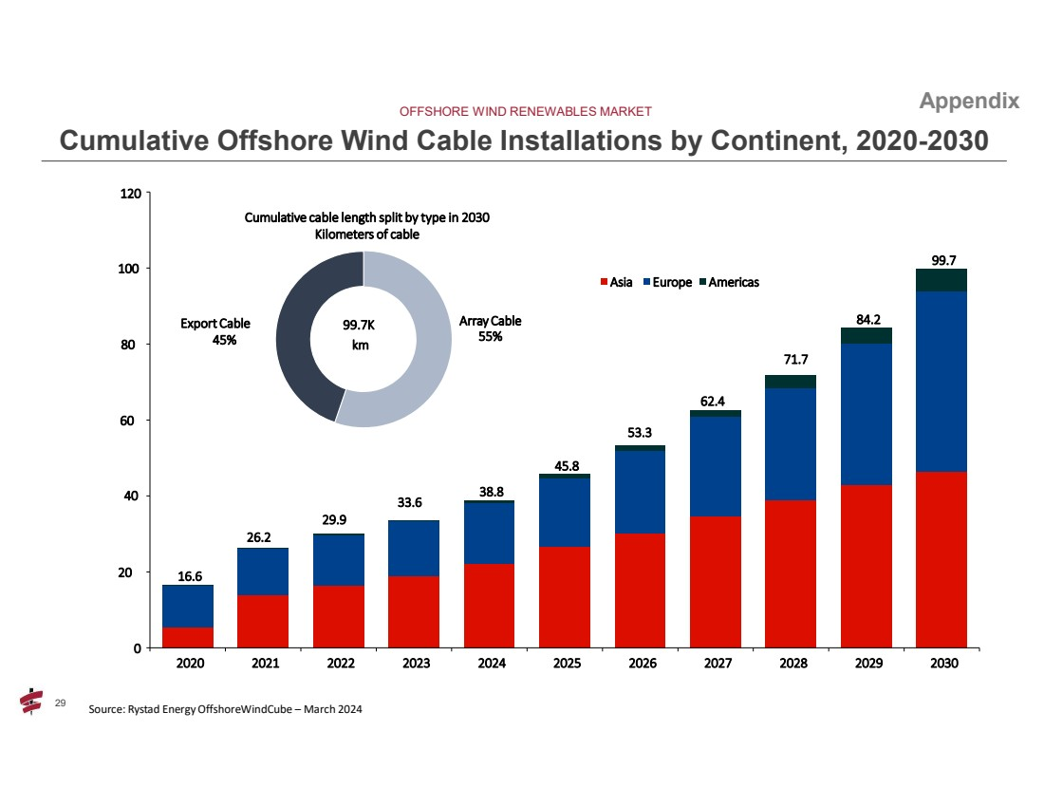 | 29 29 OFFSHORE WIND RENEWABLES MARKET Cumulative Offshore Wind Cable Installations by Continent, 2020-2030 Appendix 16.6 33.6 29.9 26.2 38.8 53.3 45.8 71.7 62.4 84.2 99.7 0 20 40 60 80 100 120 2020 2021 2022 2023 2024 2025 2026 2027 2028 2029 2030 Asia Europe Americas Array Cable 55% Export Cable 45% 99.7K km Cumulative cable length split by type in 2030 Kilometers of cable Source: Rystad Energy OffshoreWindCube – March 2024

